22.47: a) (i) 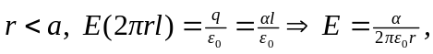 radially outward.
(ii) 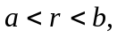there is not net charge enclosed, so the electric field is zero.
(iii) 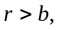there is no net charge enclosed, so the electric field is zero.

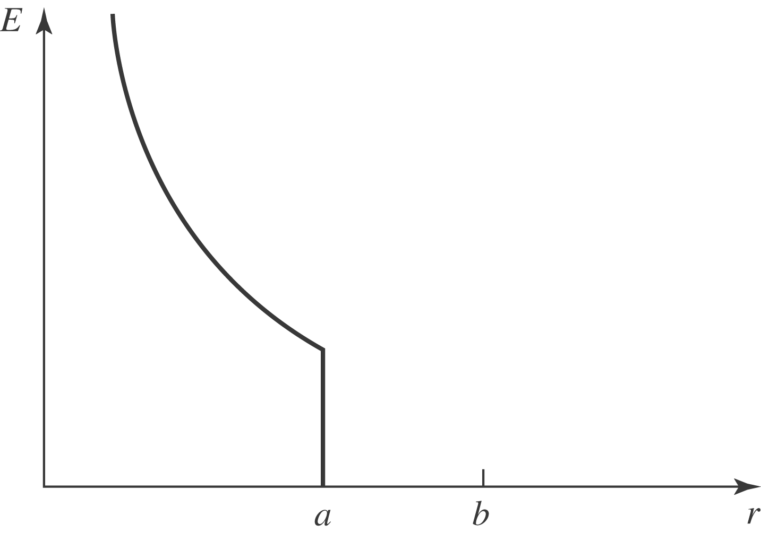

b) (i) Inner charge per unit length is
(ii) Outer charge per length is ZERO.

